***Rubik 3x3***

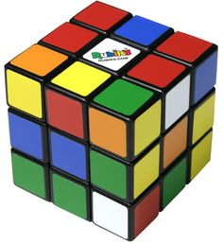

*Rubik 3×3 is made of plastic material. This is a kind of game that trains your mind and ability to concentrate. Very suitable as a gift for friends, children.*